Title : Disk Usage Alert Script
Problem Statement
Production systems run out of disk space without warning.
Objectives
The script performs the following:
- Monitors disk usage across mounted file systems
- Compares usage against a predefined threshold
- Generates an alert when threshold is exceeded
- Logs alert information with timestamp
- Supports automated execution via cron scheduler

Script Implementation
- File Name - disk_alert.sh

Script Code

#!/bin/bash

# ==============================

# CONFIGURATION

# ==============================

THRESHOLD=80

LOG_FILE="/var/log/disk_alert.log"

EMAIL=""

HOSTNAME=$(hostname)

DATE=$(date '+%Y-%m-%d %H:%M:%S')

# ==============================

# DISK USAGE CHECK

# ==============================

df -hP | awk 'NR>1 {print $1, $5, $6}' | while read filesystem usage mountpoint

do

used_percent=$(echo $usage | tr -d '%')

if [ "$used_percent" -ge "$THRESHOLD" ]; then

MESSAGE="[$DATE] ALERT: Disk usage high on $HOSTNAME | FS=$filesystem | Mount=$mountpoint | Usage=$usage"

echo "$MESSAGE"

echo "$MESSAGE" >> "$LOG_FILE"

if [ -n "$EMAIL" ]; then

echo "$MESSAGE" | mail -s "Disk Usage Alert on $HOSTNAME" "$EMAIL"

fi

fi

done
Sample Output:
[2026-02-18 12:10:02] ALERT: Disk usage high on server01 | FS=/dev/sda1 | Mount=/ | Usage=85%

output
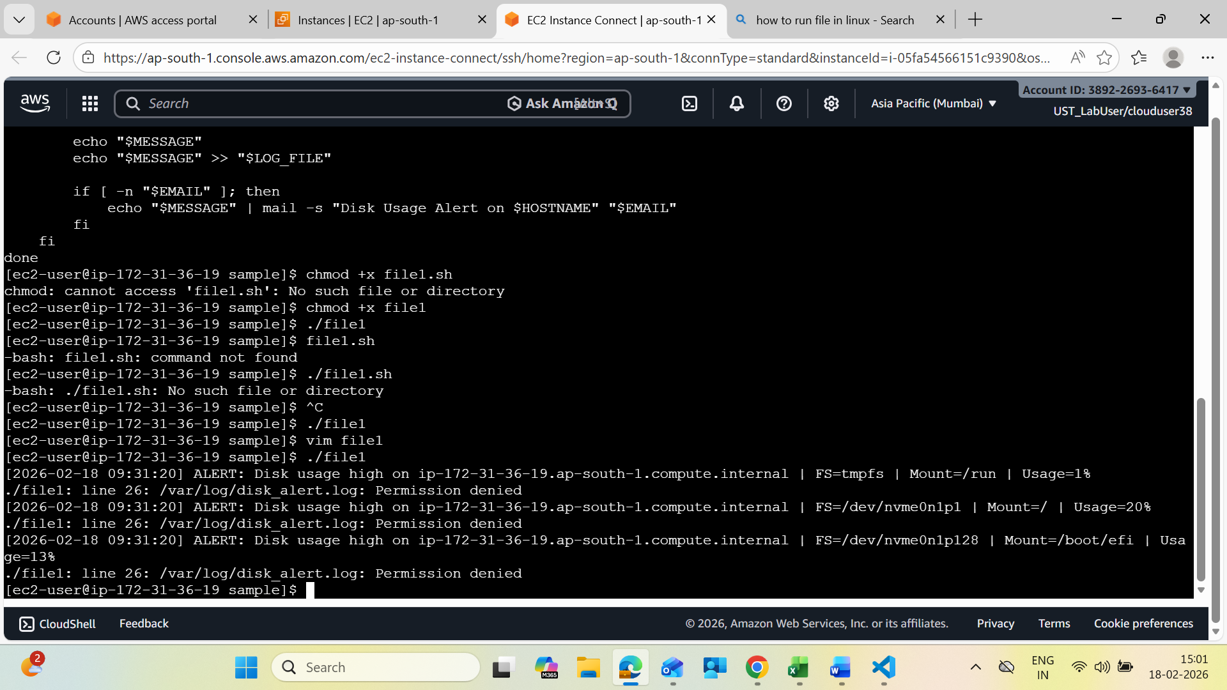

Expected Behavior
Condition | Action
Usage below threshold | No alert
Usage equals or exceeds threshold | Alert generated
Cron enabled | Continuous monitoring

Security and Reliability Considerations
- Ensure log file write permission
- Avoid running as root unless necessary
- Monitor log size if alerts occur frequently
- Configure mail service if email alerts enabled
Possible Enhancements
- Separate thresholds per mount point
- Slack or webhook alerts
- Automatic cleanup of large files
- Log rotation
- Inode usage monitoring
- Configuration file support
Conclusion
This script provides a simple and effective mechanism to monitor disk usage and prevent storage-related failures. It is suitable for production environments and integrates easily with cron for continuous monitoring.

